HOW TO CREATE A GIT HUB.COM

* Go to chrome and type github.com.
* Open the link and click on **sign up**.
* Now enter your email and click on **continue**.



* Now create a **password** and click on **continue**.
* Now enter your **user name** and click on **continue**.

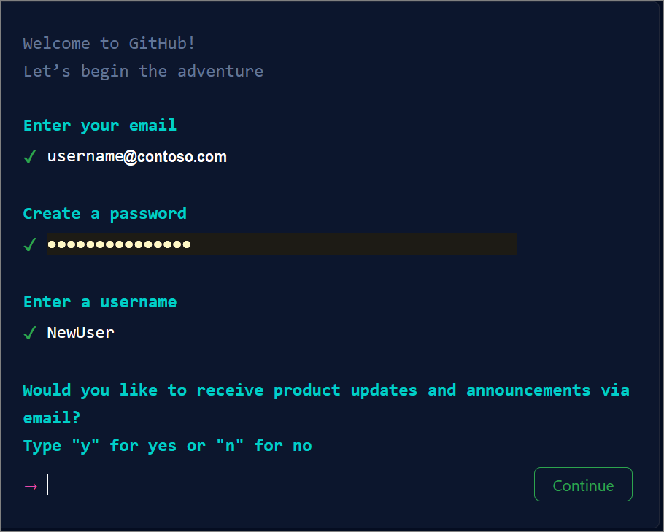

* To protect your account, it will ask you to verify the **puzzle.** Now click on **verify**.
* Complete the puzzle.
* It will ask the **username** and **password**. Fill the username and password.
* Now enter **code** which is sent to the mail.

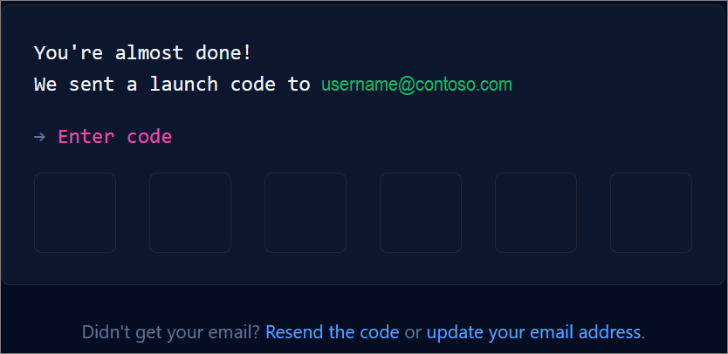

Now your **git hub** account is created.

